# Using gridmap

Open level 2 scene

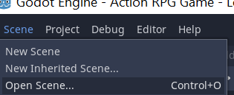

Click tilemap on left side

Click overworld 1 on right side

Click tile to select, click overworld to place

